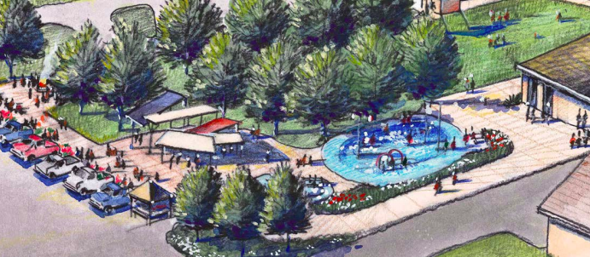

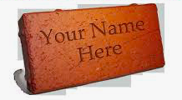
Buy a Brick Build a Park!
Engrave a brick with your corporate or personal name, a message, or “in memory of” by purchasing a brick for a contribution of $250, which will be placed in the new park for everyone to see!

Name: _______________________________________________________________

Address: _____________________________________________________________

Phone: ______________________Email: ___________________________________

- Make checks payable to: Blair Area Community Foundation
- In memo, please mark “FC Splash Pad Fund”
- Send checks to: FC Splash Pad Committee -- Attn: Tessa Rutledge
P.O. Box 472
Fort Calhoun, NE 68023
- Brick inscriptions are subject to review & approval by the
Friends of the Fort Calhoun Splash Pad Committee
- Questions – please email Tessa Rutledge at fcsplashpad@gmail.com

Please include how you would like your brick engraved.
** Note: Bricks will be engraved in ALL CAPS. 16 characters per line, which includes spaces and punctuation. 3 lines Max.

Line 1

Line 2

Line 3

