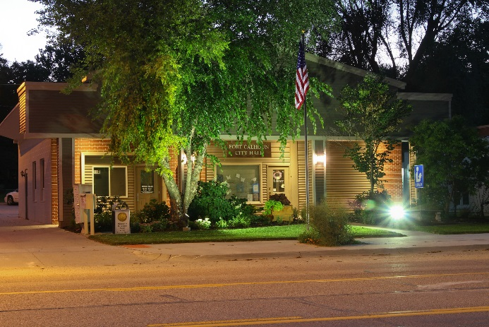
Thank you for your tax deductible donation.
Please fill out form and mail with your check to the above address.
Be sure to note which group you would like your donation to go to.

Name:
Address:
Phone:
Email:
I would like my donation in the amount of $___________.
To be distributed to:
- Parks Fund
- Enhancement Committee Fund
- Christmas in Calhoun Fund

