Please fill out form and mail with your check to the above address.
Name:
Address:
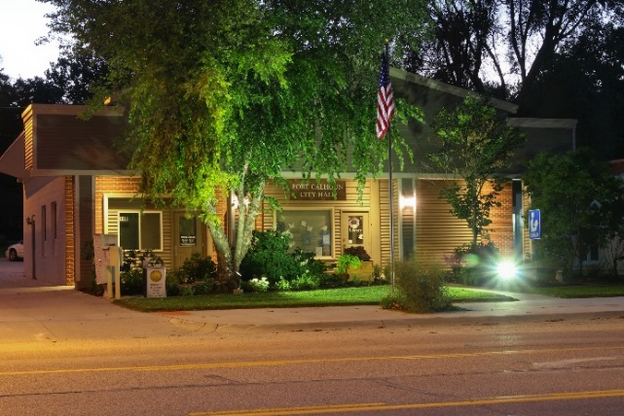
Phone:
Email:
I would like my donation in the amount of $___________.
To be distributed to:
Thank you for your tax
deductible donation!

- Parks Fund
- Enhancement Committee Fund
- Christmas in Calhoun Fund

